PRESS RELEASE 26/10/20: Cael O’Sullivan/Hidden Track

NEW COMEDY HORROR GAME INSPIRED BY DEV’S EXPERIENCES OF AGORAPHOBIA AND DEPRESSION DURING LOCKDOWN
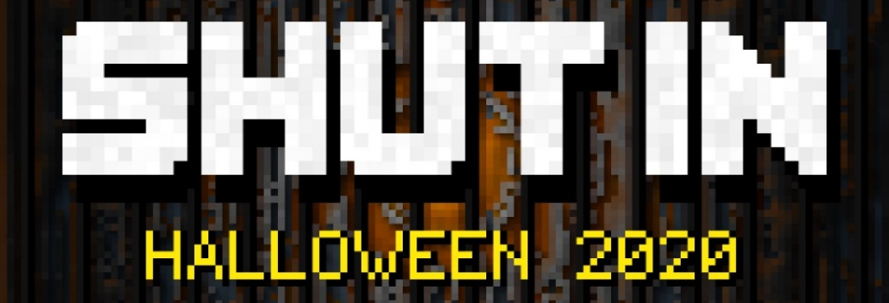

For immediate release
Release
An indie dev has created a new game inspired by their experience of lockdown restrictions during the COVID-19 pandemic.
SHUT IN, created by Cael O’Sullivan launches on the 30th October on Steam. The short narrative-led game is a satirical look at the struggles of self-care, motivation, and leaving home. Borrowing themes from survival games and point-and-click adventures, the game takes on a decidedly dark yet irreverent tone.
Cael’s personal experiences with agoraphobia are woven throughout the game. It provides an alternative narrative during a time when many are struggling with their mental health more than ever. Cael also consulted with a mental health professional to ensure the game struck the right balance tonally.
Cael O’Sullivan says: “I don't want to make a game about what you should be doing instead of being depressed. I want to try and capture how it actually feels when you're in it, and show how hard simple things can become. But also make it a fun and funny experience. It's a tough balance to try and perfect.”
The game has been supported by Hidden Track, an award-winning interactive theatre company, that has had to stop their theatre work due to COVID-19 restrictions in the UK but has continued to support creatives during this economically challenging time. SHUT IN is a very timely and surprisingly amusing take on being trapped inside, and a perfect distraction during a quarantine Halloween.
The game will release October 30th (2020)
Steam: https://store.steampowered.com/app/1438190/SHUT_IN/
Price: $4.99/£3.99/€3.99
Game Description
SHUT IN combines mundane household tasks with sinister, surreal horror imagery in an adventure game where you must explore a twisted version of your own home, solving puzzles to escape while being constantly heckled by a sarcastic, judgemental narrator.
Your task seems simple: Get out of bed, go outside, and get some fresh air. However, the further you get from the safety of your own bedroom, the harder that task becomes. Going and having a shower becomes difficult when your shower spews out swarms of hideous bugs. It’s difficult to make yourself breakfast when your oven keeps exploding and killing you. Oh, and someone replaced your front door with a drawing of your front door. Drawings don’t open.
These simple daily routines becoming mammoth, terrifying tasks ties into the games key themes of depression and isolation. SHUT IN has been made in consultation with mental health professional Anoushka Bonwick, who has developed and delivered training programs on mental health support, and worked with companies including MIND and Student Minds.
Created by Cael O’Sullivan
Music by Luc Wilkinson
Mental Health Consultancy by Anoushka Bonwick
Supported by Hidden Track
More info, images + animated GIFs at hiddentrack.org.uk/SHUTIN-PressKit

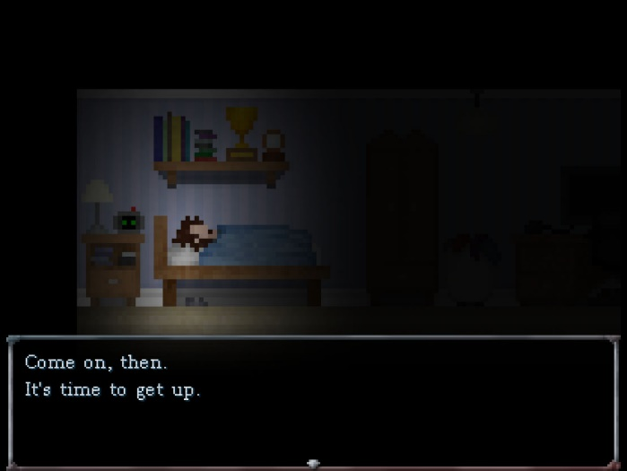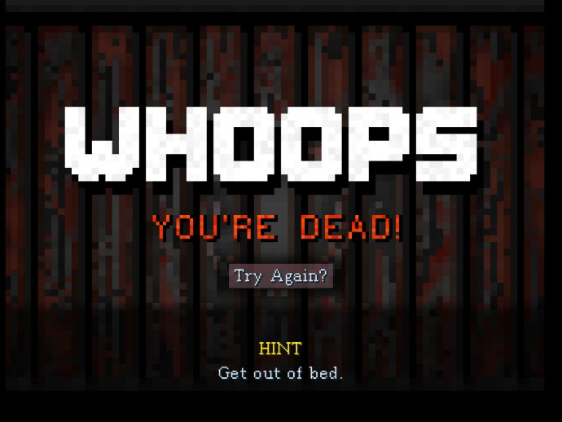
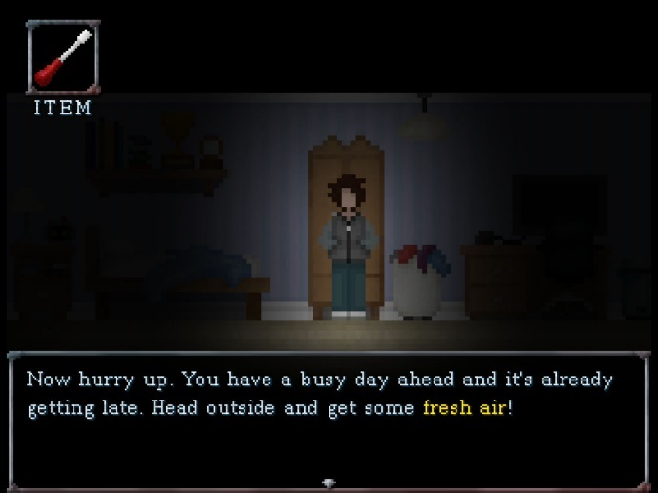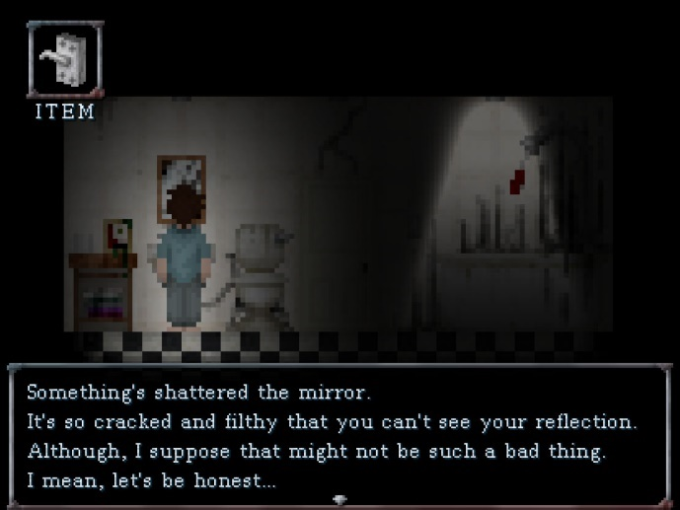
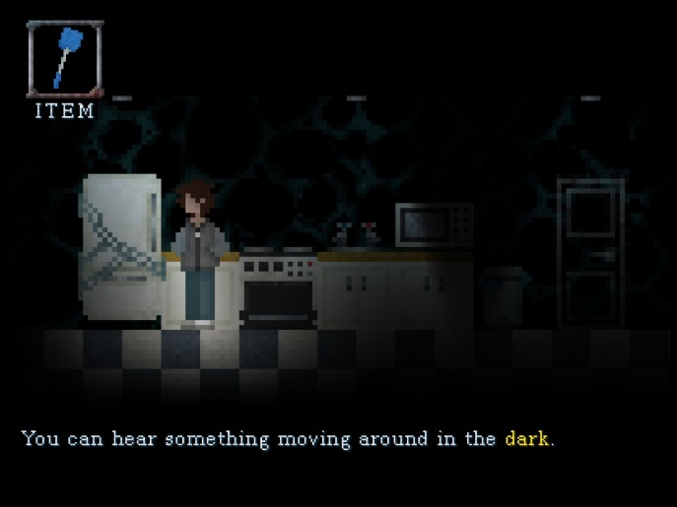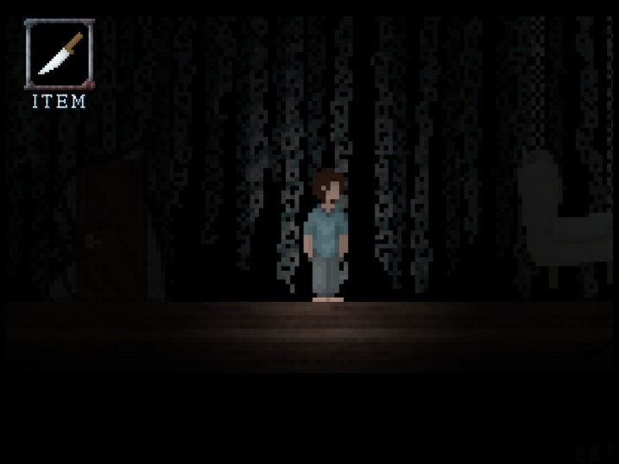

More info, images + animated GIFs at hiddentrack.org.uk/SHUTIN-PressKit

-ends-

