PRESS RELEASE 31/03/21: Hidden Track
-For immediate release-
WHATEVER our players decide, that’s what happens next in our story.
Anarchic Adventure Game HOW TO WIN on Steam NOW!
Trailer: https://www.youtube.com/watch?v=4zfTyVrutco
Created by multi-award winning interactive theatre company Hidden Track, and indie dev Cael O’Sullivan, How to Win: Season One is now on Steam for $8.99/€6.99/£6.49.
How to Win is an anarchic adventure/gaming experiment where anyone who plays can decide the rules of the world, and which direction the story goes.
Whatever our players decide, WHATEVER that may be, that is the world that gets created.
Explore the worlds we’ve made so far, find out how they ended, then tell us what to do different in the next world. Anyone can tell us how to play. Only a few will show us how to win.
When COVID closed all the theatres last year, UK-based, multi-award winning theatre company Hidden Track looked to indie game development as a new way of reaching audiences.
Teaming up with indie dev Cael O’Sullivan, creator of comedy/horror game SHUT IN (9.2/10 – FullSync, 9/10 – Cubed3, 4/5 – Adventure Gamers) they began creating ‘How to Win’ – an episodic adventure game/visual novel where each new chapter was based on ideas sent in and voted on by their players.
Each new story turn would create a new obstacle, and they their players to offer suggestions for what to do next. Those suggestions were put to a public vote, and whichever won decided what happened next.
This created a world of talking potatoes and northern elephants, in a game where you click buttons in a money factory, control the lighting and sound desk of a news channel, and fight a dragon alongside a monster drawn by a 5-year-old.
When this experiment started, the UK was in its first full national lockdown, and as the game progressed, the George Floyd Protests rocked the world, and we all started coming to terms with the new world we were facing because of COVID-19.
These groundbreaking political events had a very clear effect on the suggestions people sent in, and the subject matter of the game, which combines the chaotic energy of an improv show with a surprisingly frank and nuanced discussion of the unfolding global situation, and the role of politics within gaming.
Hidden Track’s Artistic Director, Elliot Hughes, says:
“We wanted to see how we could recreate the feel of a live show within a game that could be played by people around the world, from inside their own homes. By allowing all of our players to contribute ideas, vote on the ideas they liked, and see their suggestions have a real, massive impact on the story; we tried to make our players feel like one community, all making something together.”
Originally commissioned by two UK theatres – HOME, Manchester and Harrogate Theatres – each episode was originally playable in-browser within those theatre websites.
Now, all 5 chapters of How to Win: Season One have been compiled and remastered on Steam, along with new functionality, in-game achievements, unseen cut content, unlockable bonus scenes, and a call for brand new player suggestions to be used for Season Two in Summer 2021.
If you missed How to Win the first time round, this is the ideal chance to play through the world they created, see how it ended, and then send your suggestions in for the next world.
How to Win: Season One is on Steam NOW. Season Two will begin Summer 2021.
https://store.steampowered.com/app/1386510/How_to_Win_Season_One/
-
Hidden Track is a multi-award winning interactive theatre company based in Manchester, UK. (Best New Writing, Manchester Fringe; Best Newcomer, Brighton Fringe; Nominated for Venues North Edinburgh Fringe Award; ★★★★★ Everything Theatre; ★★★★★ Broadway World; ★★★★★ Spy in the Stalls)
Cael O’Sullivan is an indie game developer, and creator of acclaimed comedy horror adventure SHUT IN, which explores depression and isolation by trapping the player in their own home.
(9.2/10 – FullSync, 9/10 – Cubed3, 4/5 – Adventure Gamers)

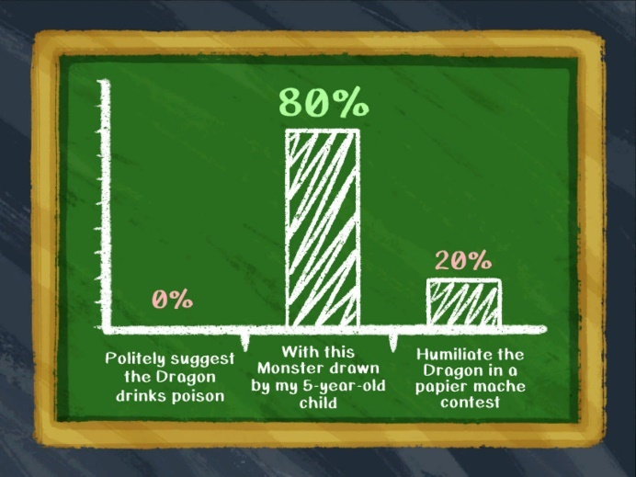 | 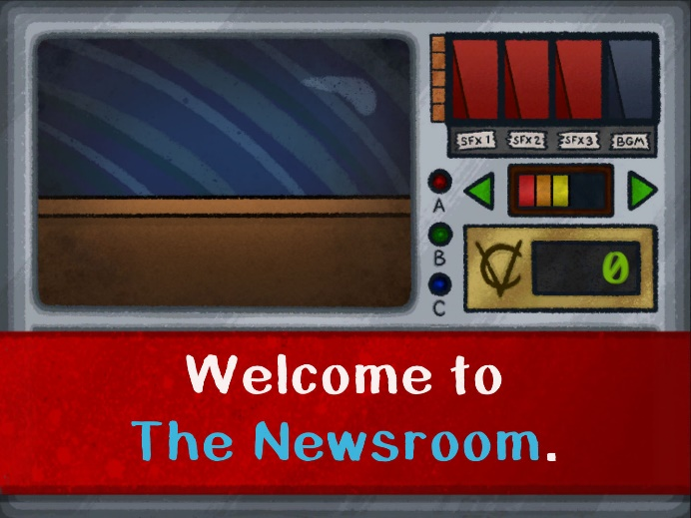
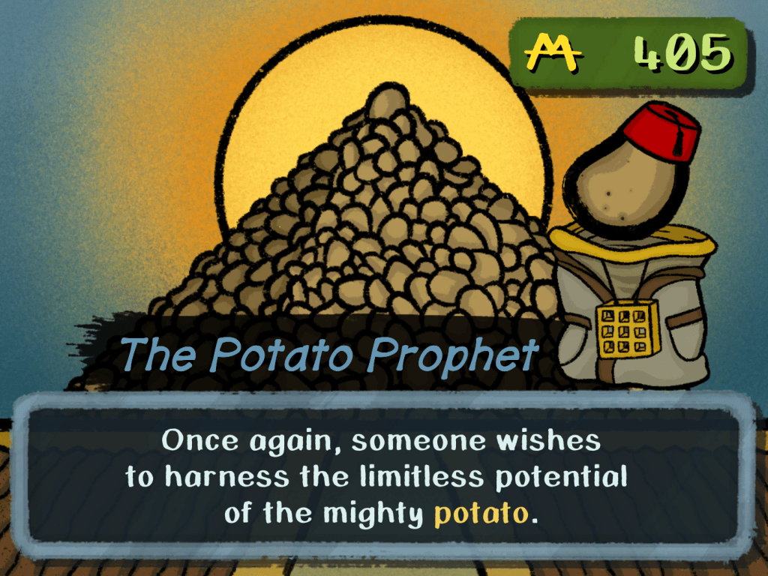 | 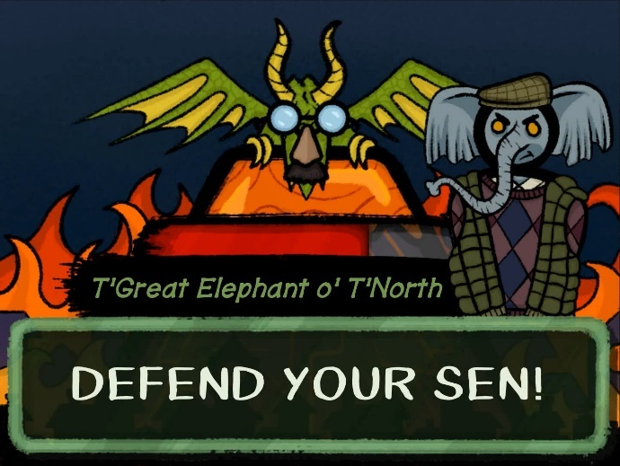

“A cleverly subversive pantomime that plays with the conventions of gaming and theatre.” Exeunt Magazine
“The approach to politics in How to Win: Season One is actually remarkably nuanced and intriguing, and I can’t adequately do it justice without spoiling some pretty interesting parts of the game. How to Win: Season One is a game best appreciated going in totally blind.” Killa Penguin
“An ambitious and original experience... very well-written, and unrestricted by stereotypical notions about gamers.” Indie Hive
“How to Win is a game that deals with… uhh, **** how do I explain this. ****.”
Indie Gamer Team
More images + GIFs available in 1080p and 4:3 (native) at hiddentrack.org.uk/HowtoWin-PressKit
Playable demo available at
https://store.steampowered.com/app/1386510/How_to_Win_Season_One/
-ends-

